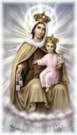

Church of our lady of mount carmel
Bronx, New York

Memorial mass

+ Tonino sementilli +

Saturday, December 4th
10:30 a.m.

